## The Font Menu

Hello

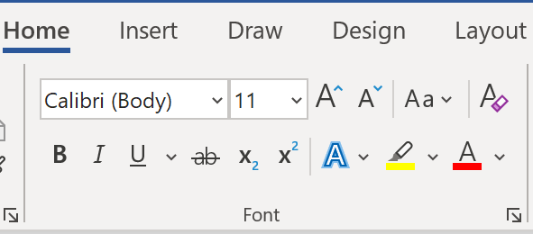

##### Keyboard Shortcuts

* CTRL + B Bold text
* CTRL + I Italicise text
* CTRL + U Underline
* CTRL + > Increase font size
* CTRL + < Decrease font size
* CTRL + = Subscript
* CTRL + SHIFT + = Superscript

##### Practice exercises

#### Change the font and size of the following text to Times New Roman size 15:

Lorem ipsum dolor sit amet, consectetuer adipiscing elit. Maecenas porttitor congue massa. Fusce posuere, magna sed pulvinar ultricies, purus lectus malesuada libero, sit amet commodo magna eros quis urna.

#### Bold, Italicise and underline the text below

***Nunc viverra imperdiet enim. Fusce est. Vivamus a tellus.***

#### Make the following text upper case and red

PELLENTESQUE HABITANT MORBI TRISTIQUE SENECTUS ET NETUS ET MALESUADA FAMES AC TURPIS EGESTAS. PROIN PHARETRA NONUMMY PEDE. MAURIS ET ORCI.

AENEAN NEC LOREM. IN PORTTITOR. DONEC LAOREET NONUMMY AUGUE.

SUSPENDISSE DUI PURUS, SCELERISQUE AT, VULPUTATE VITAE, PRETIUM MATTIS, NUNC. MAURIS EGET NEQUE AT SEM VENENATIS ELEIFEND. UT NONUMMY.

## The Paragraph Menu

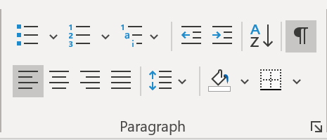

##### Practice exercises

#### Right align the text below

Lorem ipsum dolor sit amet, consectetuer adipiscing elit. Maecenas porttitor congue massa. Fusce posuere, magna sed pulvinar ultricies, purus lectus malesuada libero, sit amet commodo magna eros quis urna.

#### Indent and then center the text below

Pellentesque habitant morbi tristique senectus et netus et malesuada fames ac turpis egestas. Proin pharetra nonummy pede. Mauris et orci.

#### Remove the indent from the text below

Aenean nec lorem. In porttitor. Donec laoreet nonummy augue.

#### Justify the text below and change the line spacing to 3

Suspendisse dui purus, scelerisque at, vulputate vitae, pretium mattis, nunc. Mauris eget neque at sem venenatis eleifend. Ut nonummy.

#### Convert the following shorcuts into a bulleted list and include tabs to align the descriptions correctly

##### Keyboard Shortcuts

* CTRL + L Align left
* CTRL + R Align Right
* CTRL + E Align Centre
* CTRL + J Justify
* CTRL + * Show paragraph marks and other hidden formatting symbols
* Tab Indent
* SHIFT + Tab Remove indent
* CTRL + SHIFT + C Copy all formatting
* CTRL + SHIFT + V Paste all formatting

## Introduction to Styles

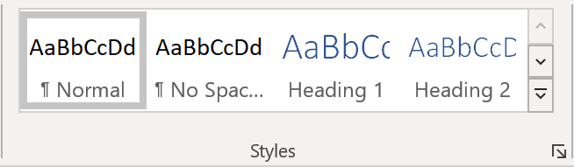

##### Practice exercises

# Section Heading (make this heading 1)

## Paragraph 1 (make this heading 2)

Lorem ipsum dolor sit amet, consectetuer adipiscing elit. Maecenas porttitor congue massa. Fusce posuere, magna sed pulvinar ultricies, purus lectus malesuada libero, sit amet commodo magna eros quis urna.

## Paragraphs 2 and 3 (make this heading 2)

Nunc viverra imperdiet enim. Fusce est. Vivamus a tellus.

Pellentesque habitant morbi tristique senectus et netus et malesuada fames ac turpis egestas. Proin pharetra nonummy pede. Mauris et orci.

### Paragraphs 4 and 5 (make this heading 3)

Aenean nec lorem. In porttitor. Donec laoreet nonummy augue.

Suspendisse dui purus, scelerisque at, vulputate vitae, pretium mattis, nunc. Mauris eget neque at sem venenatis eleifend. Ut nonummy.