Lesson 4c: Formatting visuals in Power BI

Workout Solution Steps

- Create a new Power BI Report and from the Home Tab use Get Data to connect to an Excel workbook called Module 2 Lesson 4c Workout.xlsx. Select the L4c Assets worksheet and load into the report:

- Create the following 2 visuals:
- A column chart which shows the total Market Value USD by Asset Class L1
- A pie chart which shows the % Market Value USD by Location

- Res-size and the position the visuals so they are similar to the example below:
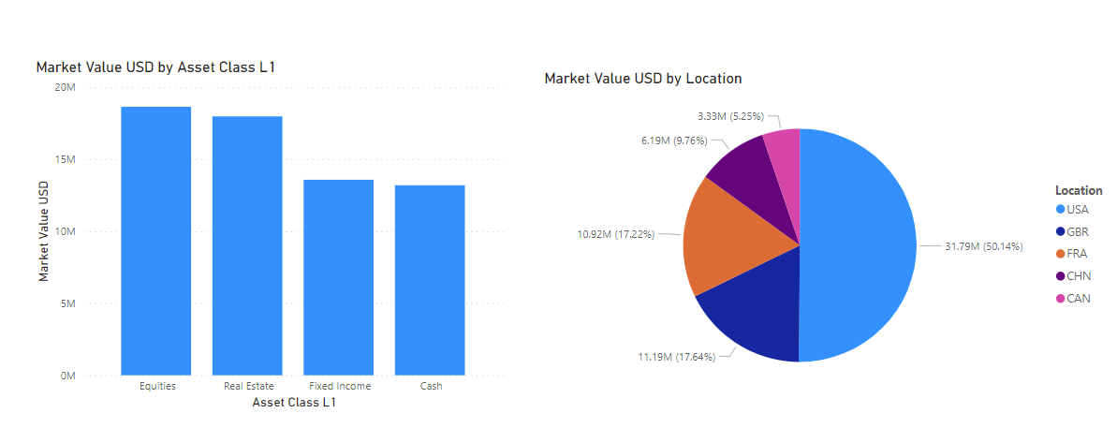

- Select the column chart and click on the Formatting icon on the Visualizations Pane. Select the Visual Section and make the following changes:
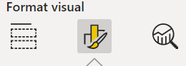
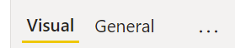

- Expand the Y Axis section, scroll down and take the Title off:
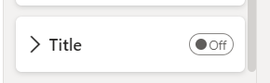

- Do the same for the X Axis section – take the Title off

- Switch to the General Section and make the following changes:
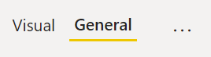

- Expand the Title Section and change the Title to “Asset Class L1 USD Value”, center aligned and size 16

- Expand the Effects Section and turn the Visual Border ON
- Select the Pie chart and make the following changes:

Visual Section
- Expand the legend section and change the position to Top Centre

- Expand the Detail Labels section and change the label contents to Percent of Total and the position to Inside. Use the Values section to change it to 0 decimals

General Section
- Expand the Title Section and set the Title to center aligned and size 16

- Expand the Effects Section and turn the Visual Border ON

- Use the Insert Tab to insert a Text Box and add some text “Assets Analysis”. Change the text to size 36, center aligned and bold. Position it so it sits at the top of the page

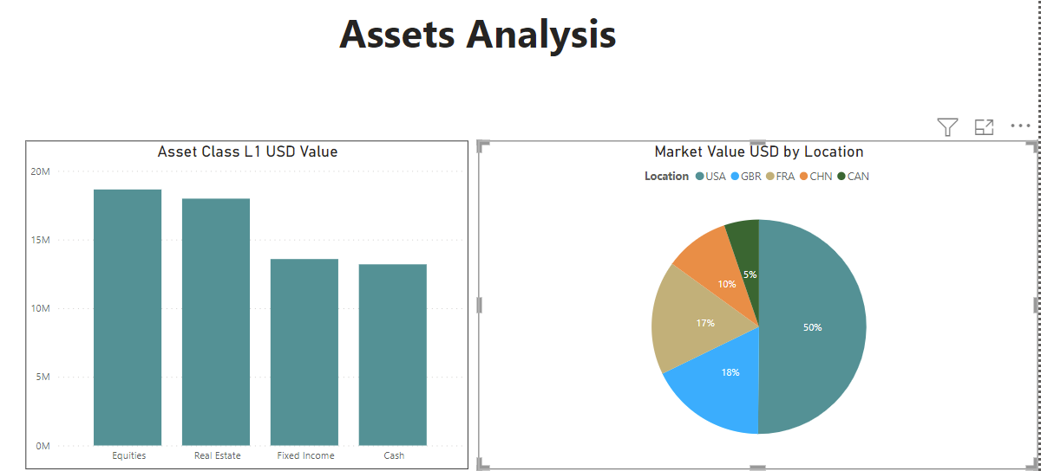
- Use the View Tab to apply a theme of your choice to the report (the example below uses HighRiseL

- Save the Report as Module 2 Lesson 4c Report.pbix

